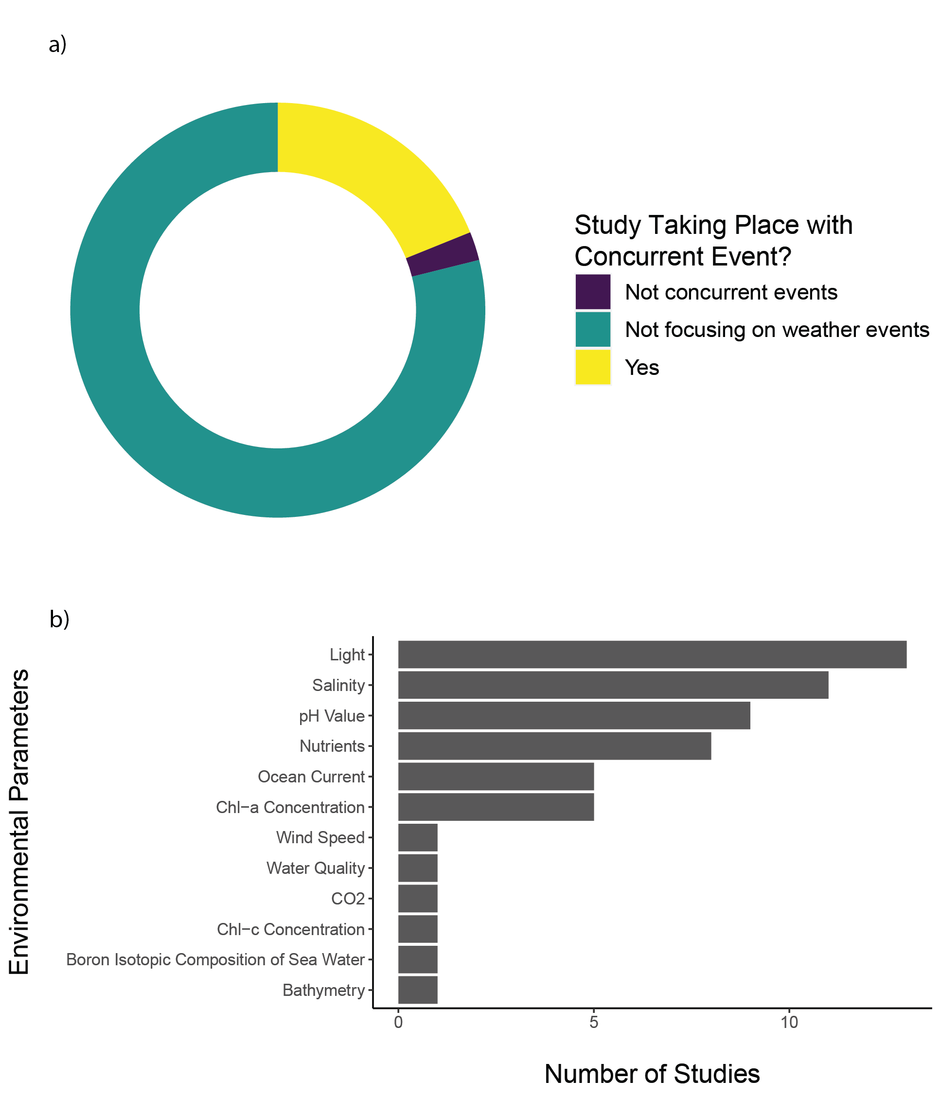

Figure 11 a) Portion of publication focusing on weather event. b) Other parameters recorded in the literature covered in this systematic map.